**Report**

**INTRODUCTION**

**Overview**

    Life expectancy is a statistical measure of the average time a human being is expected to live, Life expectancy depends on various factors: Regional variations, Economic Circumstances, Sex Differences, Mental Illnesses, Physical Illnesses, Education, Year of their birth and other demographic factors. This problem statement provides a way to predict average life expectancy of people living in a country when various factors such as year, GDP, education, alcohol intake of people in the country, expenditure on healthcare system and some specific disease related deaths that happened in the country are given.

**Purpose**

- To Predict the life expectancy of the person.

**LITERATURE SURVEY**

➤ **Existing problem:**

       The Problem is to create a machine learning model to predict the life expectancy of the person.

➤ **Proposed solution**

We are given various parameters such as Country, Year, Status, Adult Mortality, Infant deaths, Alcohol, percentage expenditure, Hepatitis B, Measles , BMI, Under Five, Polio, Total expenditure, Diphtheria, HIV/AIDS, GDP,  Population, thinness  1-19 years, thinness 5-9 years, Income composition of resources, Schooling. we will use a supervised algorithm to predict the Life Expectancy of the person using an Auto AI Experiment. Then we will create a Node-Red application to integrate it with the Auto AI.

**THEORITICAL ANALYSIS**

**➤** **Block diagram**

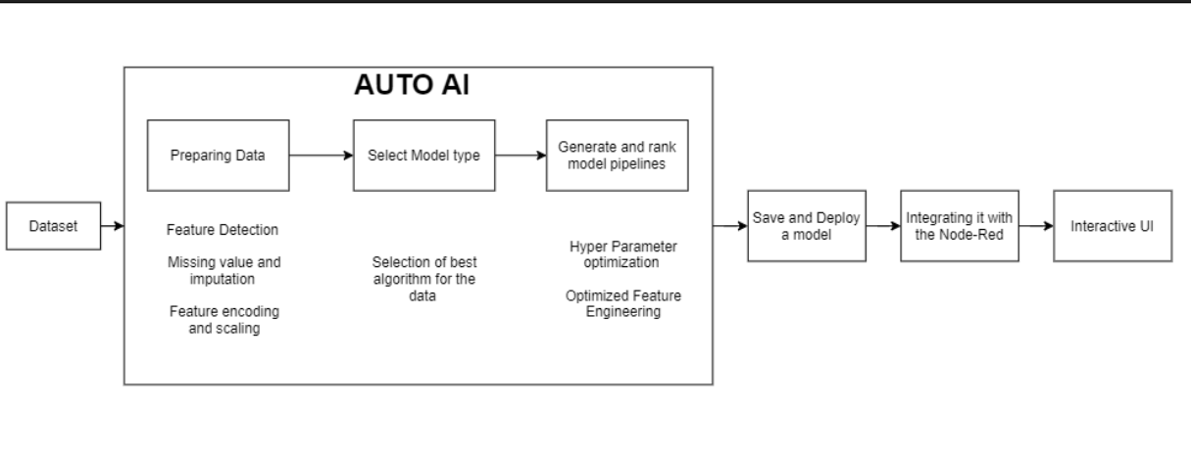

**EXPERIMENTAL INVESTIGATIONS**

      The model is working quite well on the testing data with an Root Mean Square Error of 1.830 and 96% of the variance is explained by the machine learning model.

**FLOWCHART**

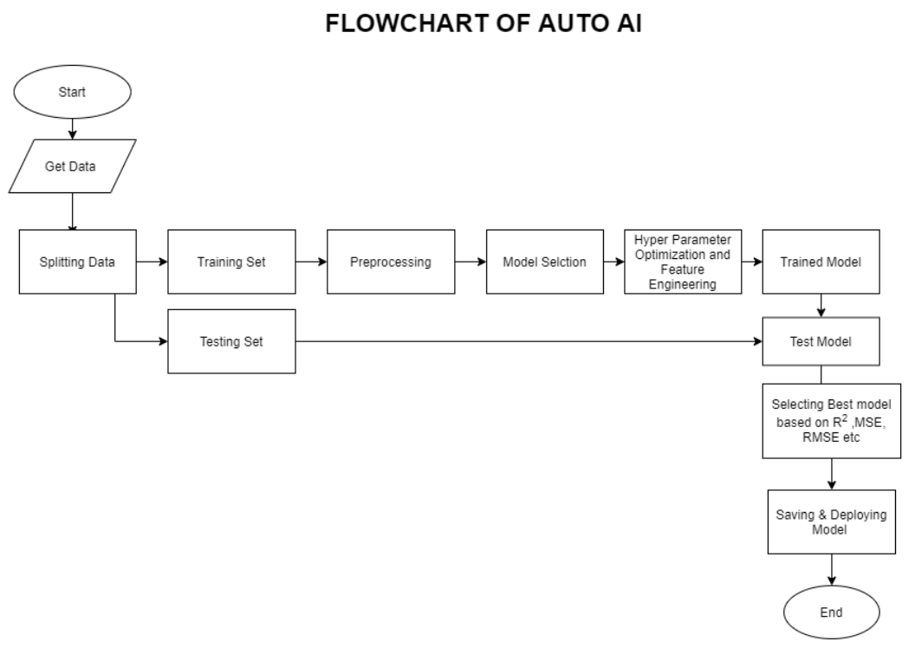

**RESULT**

  We have created an Machine Learning Algorithm(Extra Tree Regressor)  and an UI in Node-Red  to predict the Life Expectancy

**ADVANTAGES**

* Give Information on mortality of the population
* It used in Health industry
* Help in Retirement planning
* Help in Annuity Planning
* It is a factor which is used in calculating Human Development Index of each nation.
* It is also used in describing the physical quality of life of an area.

**DISADVANTAGES**

* Prediction are never 100% accurate
* It can be influenced by certain factor like life threating disease, accidental deaths and many more.

**CONCLUSION**

    It was a wonderful learning experience for me while working on this project. This project took me through the various phases of project development. The joy of working and the thrill involved while tackling the various problems and challenges gave me a feel of the developers’ industry. It was due to this project I came to know how professional software is designed.

**FUTURE SCOPE**

* Life Expectancy prediction can be helpful in planning of pension, health, social services & future mortality.

**BIBILOGRAPHY**

* <https://www.google.com/>
* <https://www.quora.com/>
* <https://www.wikipedia.org/>
* <https://www.kaggle.com/>

**APPENDIX**

**Source code**

Uploaded to GitHub

Link : <https://github.com/SmartPracticeschool/llSPS-INT-2657-Predicting-Life-Expectancy-using-Machine-Learning>